

Instituto Politécnico Nacional
Escuela Superior de Computo

Materia: Bases de Datos
Profesor: Iván Diaz Toala
Equipo:
Oswaldo Gil Valentín
Rojas Tapia Italuu
Godínez Pérez Karla
Grupo: 3CV4 Fecha: 10/12/2023
Actividad: Reporte Practica 6



Descripción del sistema digital:
Básicamente son los Programas de Binario a 7 Segmentos fusionado con el BCD a 7 Segmentos pero ahora con estructura secuencial pero se le añadió un control, cuando este control sea 0, el circuito se comportará como un BIN/7SEG, cuando el control sea 1, el circuito se comportará como un BCD /7SEG y cuando en BCD se marque del 10-15 se verá un guion medio en el Display.
Cálculos de diseño:
Para BINARIO a 7 SEGMENTOS:
Cálculos de diseño:
N | A | B | C | D | a | b | c | d | e | f | g
0 | 0 | 0 | 0 | 0 | 1 | 1 | 1 | 1 | 1 | 1 | 0
1 | 0 | 0 | 0 | 1 | 0 | 1 | 1 | 0 | 0 | 0 | 0
2 | 0 | 0 | 1 | 0 | 1 | 1 | 0 | 1 | 1 | 0 | 1
3 | 0 | 0 | 1 | 1 | 1 | 1 | 1 | 1 | 0 | 0 | 1
4 | 0 | 1 | 0 | 0 | 0 | 1 | 1 | 0 | 0 | 1 | 1
5 | 0 | 1 | 0 | 1 | 1 | 0 | 1 | 1 | 0 | 1 | 1
6 | 0 | 1 | 1 | 0 | 1 | 0 | 1 | 1 | 1 | 1 | 1
7 | 0 | 1 | 1 | 1 | 1 | 1 | 1 | 0 | 0 | 0 | 0
8 | 1 | 0 | 0 | 0 | 1 | 1 | 1 | 1 | 1 | 1 | 1
9 | 1 | 0 | 0 | 1 | 1 | 1 | 1 | 0 | 0 | 1 | 1
10 | 1 | 0 | 1 | 0 | 1 | 1 | 1 | 0 | 1 | 1 | 1
11 | 1 | 0 | 1 | 1 | 0 | 0 | 1 | 1 | 1 | 1 | 1
12 | 1 | 1 | 0 | 0 | 1 | 0 | 0 | 1 | 1 | 1 | 0
13 | 1 | 1 | 0 | 1 | 0 | 1 | 1 | 1 | 1 | 0 | 1
14 | 1 | 1 | 1 | 0 | 1 | 0 | 0 | 1 | 1 | 1 | 1
15 | 1 | 1 | 1 | 1 | 1 | 0 | 0 | 0 | 1 | 1 | 1

a(A,B,C,D)∑(0,2,3,5-10,12,14,15)
b(A,B,C,D)∑(0-4,7-10,13)
c(A,B,C,D)∑(0,1,3-11,13)
d(A,B,C,D)∑(0,2,3,5,6,8,11-14)
e(A,B,C,D)∑(0,2,6,8,10-15)
f(A,B,C,D)∑(0,4-6,8-12,14,15)
g(A,B,C,D)∑(2-6,8-11,13-15)

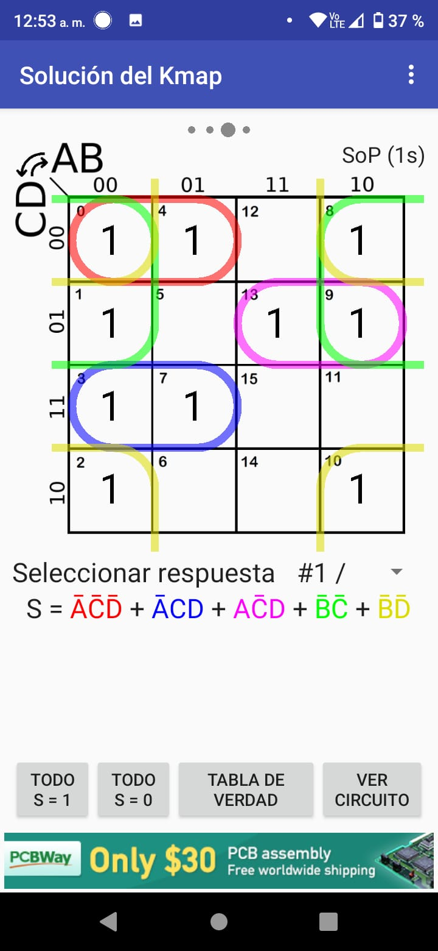
a(A,B,C,D)∑(0,2,3,5-10,12,14,15) b(A,B,C,D)∑(0-4,7-10,13)
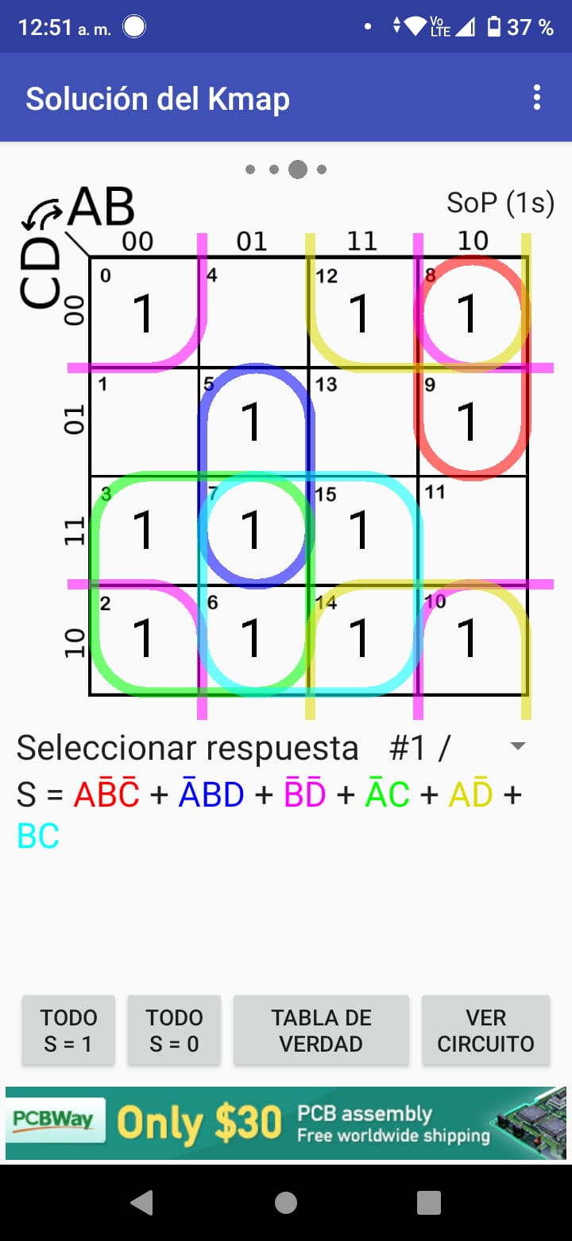

c(A,B,C,D)∑(0,1,3-11,13) d(A,B,C,D)∑(0,2,3,5,6,8,11-14)
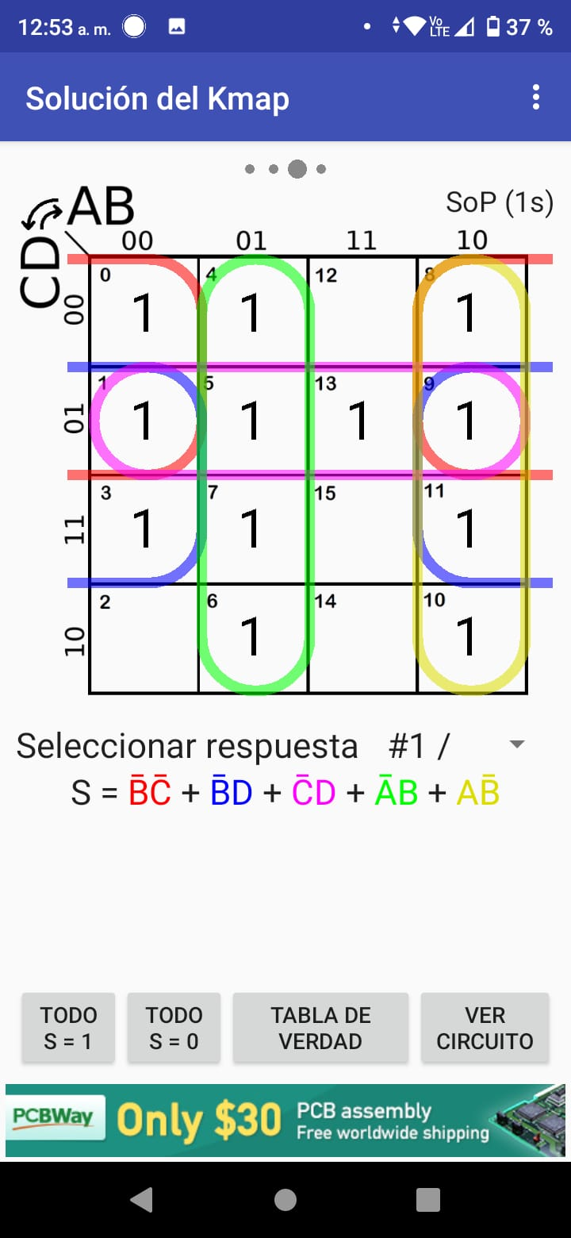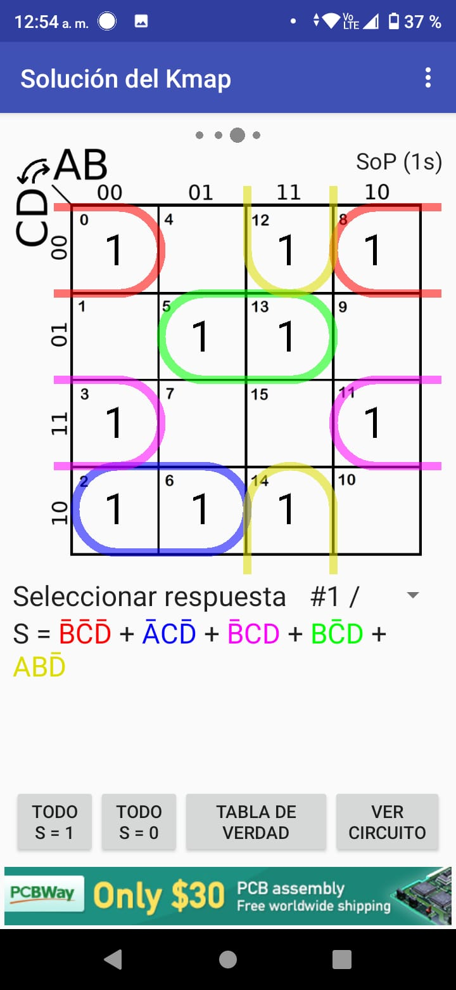

e(A,B,C,D)∑(0,2,6,8,10-15) f(A,B,C,D)∑(0,4-6,8-12,14,15)
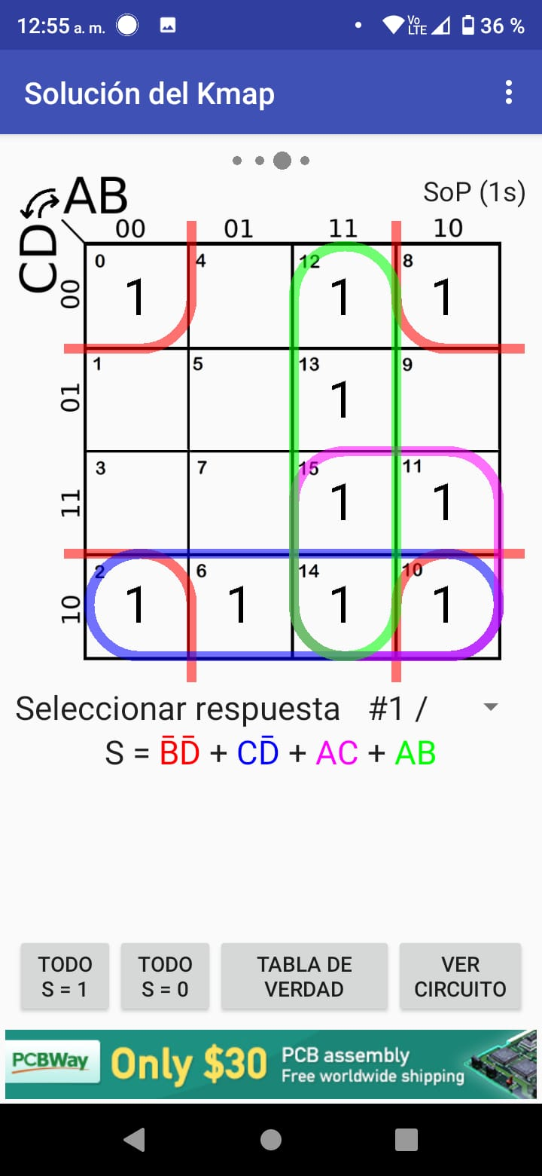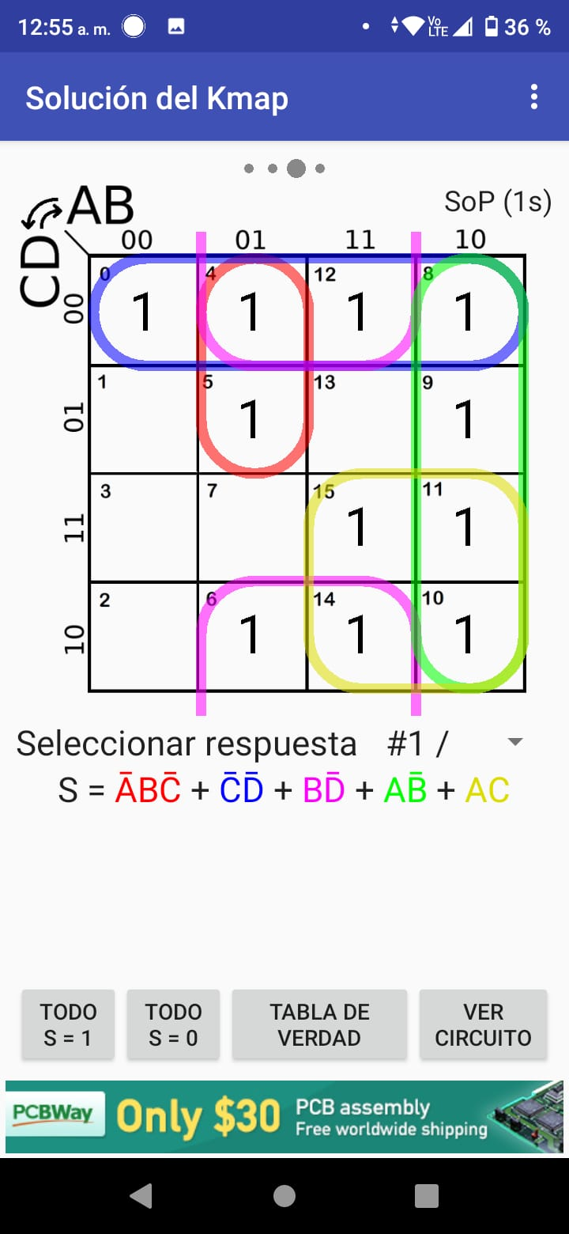

g(A,B,C,D)∑(2-6,8-11,13-15)
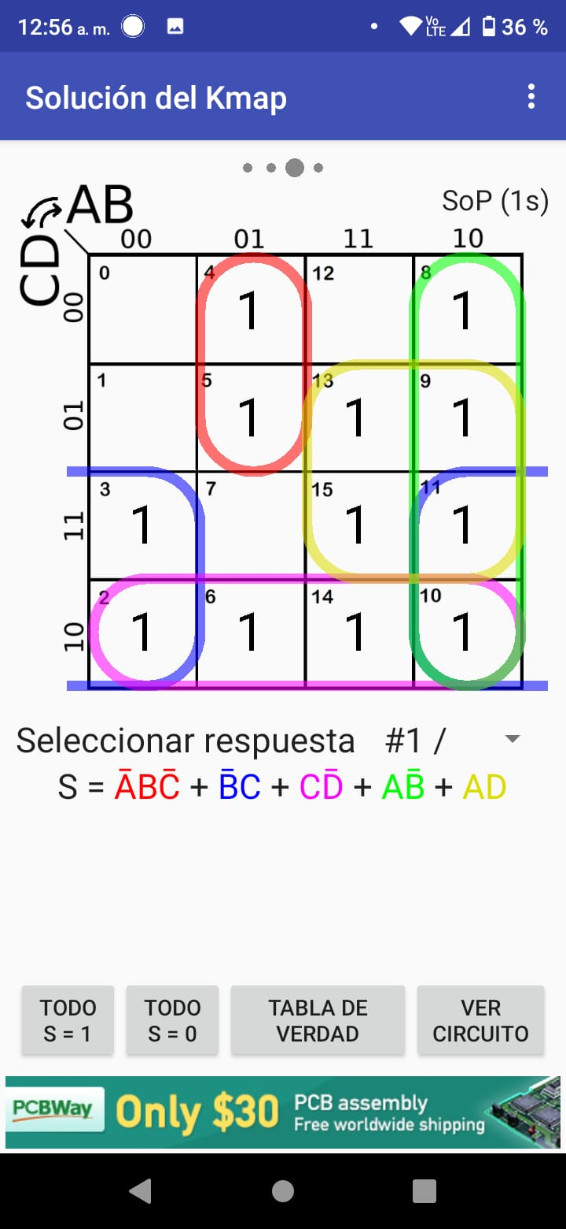

Para BCD a 7 SEGMENTOS:
 | Entradas |  |  |  | Salidas
N | A | B | C | D | Caso 1 | Caso 2
0 | 0 | 0 | 0 | 0 | 0 | 0
1 | 0 | 0 | 0 | 1 | 0 | 0
2 | 0 | 0 | 1 | 0 | 1 | 1
3 | 0 | 0 | 1 | 1 | 1 | 1
4 | 0 | 1 | 0 | 0 | 0 | 0
5 | 0 | 1 | 0 | 1 | 1 | 1
6 | 0 | 1 | 1 | 0 | 0 | 0
7 | 0 | 1 | 1 | 1 | 1 | 1
8 | 1 | 0 | 0 | 0 | 0 | 0
9 | 1 | 0 | 0 | 1 | 0 | 0
10 | 1 | 0 | 1 | 0 | X | X
11 | 1 | 0 | 1 | 1 | X | X
12 | 1 | 1 | 0 | 0 | X | X
13 | 1 | 1 | 0 | 1 | X | X
14 | 1 | 1 | 1 | 0 | X | X
15 | 1 | 1 | 1 | 1 | X | X

a(A,B,C,D)=∑(0,2,3,5-9) + β(10-15)
b(A,B,C,D)=∑(0-4,7-9) + β(10-15)
c(A,B,C,D)=∑(0,1,3-9) + β(10-15)
d(A,B,C,D)=∑(0,2,3,5,6,8) + β(10-15)
e(A,B,C,D)=∑(0,2,6,8) + β(10-15)
f(A,B,C,D)=∑(0,4-6,8,9) + β(10-15)
g(A,B,C,D)=∑(2-6,8,9) + β(10-15)

a(A,B,C,D)=∑(0,2,3,5-9) + β(10-15) b(A,B,C,D)=∑(0-4,7-9) + β(10-15)
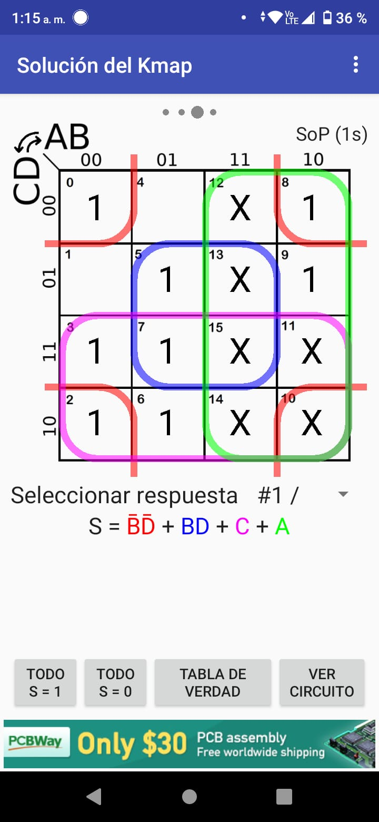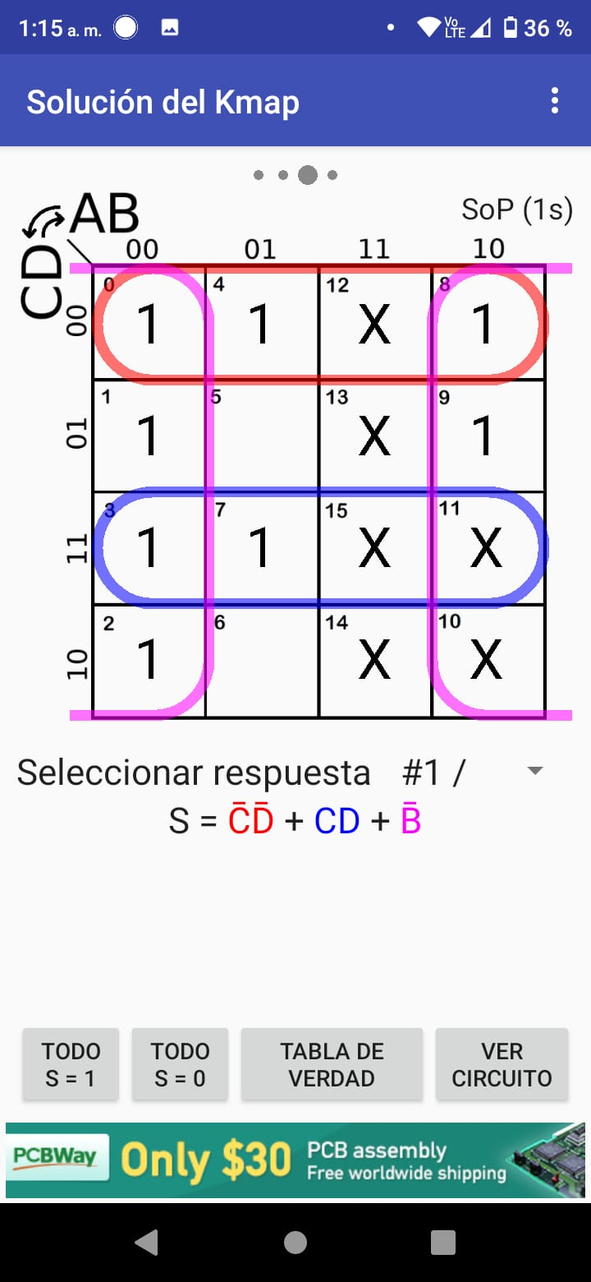
c(A,B,C,D)=∑(0,1,3-9) + β(10-15) d(A,B,C,D)=∑(0,2,3,5,6,8) + β(10-15)
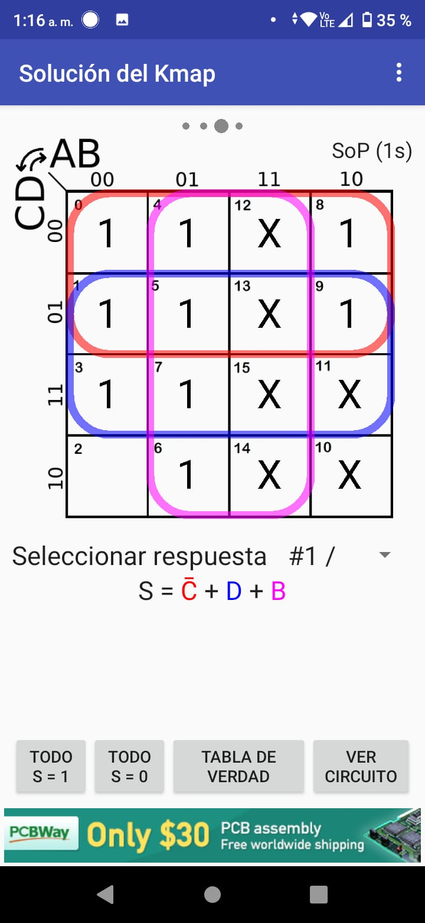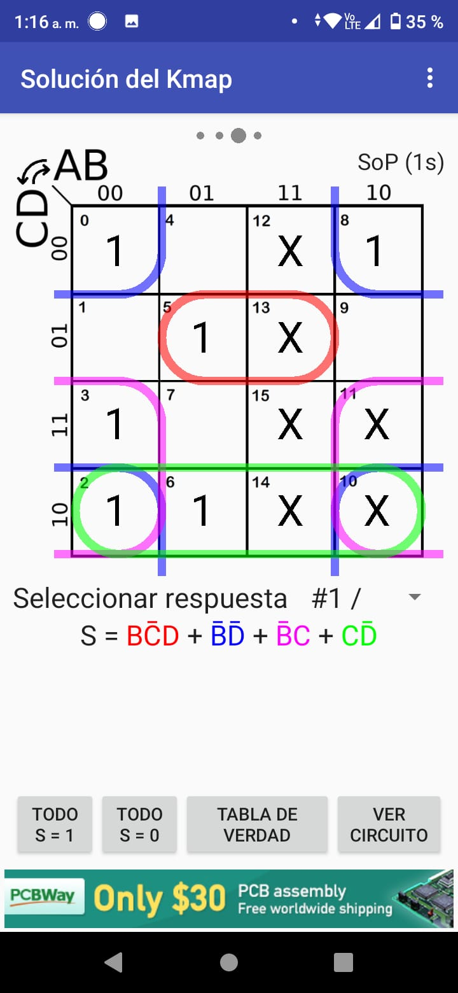

e(A,B,C,D)=∑(0,2,6,8) + β(10-15) f(A,B,C,D)=∑(0,4-6,8,9) + β(10-15)
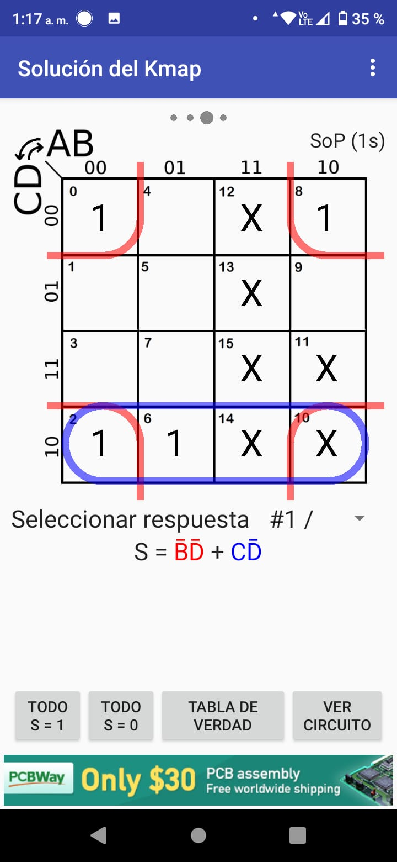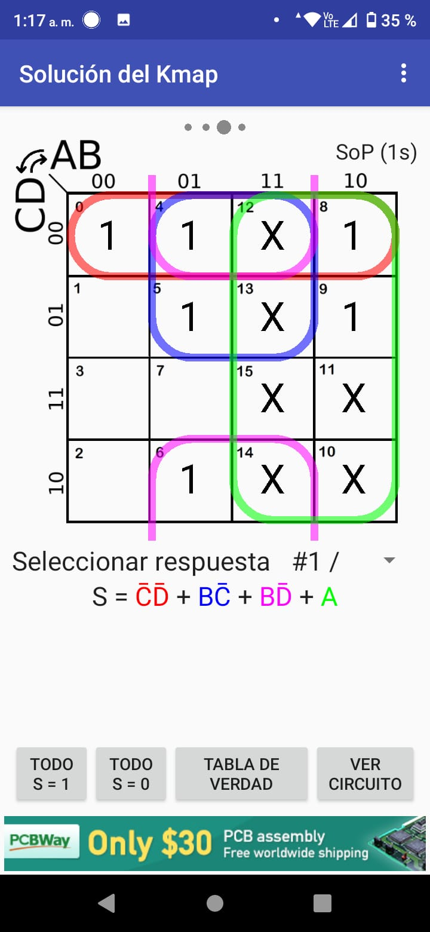
g(A,B,C,D)=∑(2-6,8,9) + β(10-15)
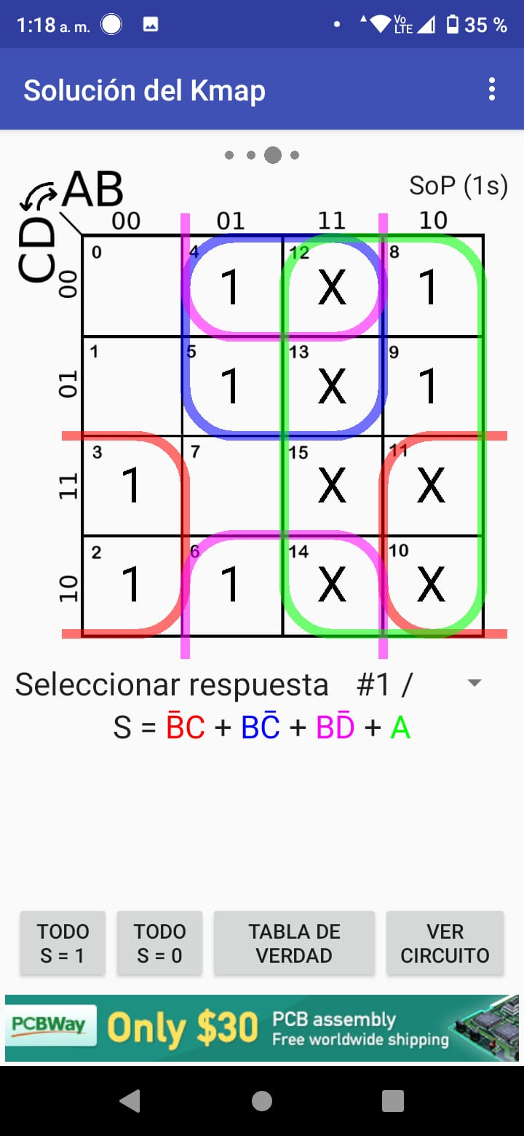

Código VHDL:
library IEEE;
use IEEE.STD_LOGIC_1164.ALL;

entity CTRL7SEG is
Port ( CTRL : in STD_LOGIC;
A : in STD_LOGIC;
B : in STD_LOGIC;
C : in STD_LOGIC;
D : in STD_LOGIC;
seg : out STD_LOGIC_VECTOR (6 downto 0));
end CTRL7SEG;

architecture CTRL7SEG of CTRL7SEG is
begin
process(CTRL, A, B, C, D)
variable bin : STD_LOGIC_VECTOR (3 downto 0);
begin
bin := A & B & C & D;
if CTRL = '0' then -- Convertidor Binario a 7 Segmentos
case bin is
when "0000" => seg <= "0111111"; -- 0
when "0001" => seg <= "0000110"; -- 1
when "0010" => seg <= "1011011"; -- 2
when "0011" => seg <= "1001111"; -- 3
when "0100" => seg <= "1100110"; -- 4
when "0101" => seg <= "1101101"; -- 5
when "0110" => seg <= "1111101"; -- 6
when "0111" => seg <= "0000111"; -- 7
when "1000" => seg <= "1111111"; -- 8
when "1001" => seg <= "1100111"; -- 9
when "1010" => seg <= "1110111"; -- A
when "1011" => seg <= "1111100"; -- b
when "1100" => seg <= "0111001"; -- C
when "1101" => seg <= "1011110"; -- d
when "1110" => seg <= "1111001"; -- E
when others => seg <= "1110001"; -- F
end case;
else -- Convertidor BCD a 7 Segmentos
case bin is
when "0000" => seg <= "0111111"; -- 0
when "0001" => seg <= "0000110"; -- 1
when "0010" => seg <= "1011011"; -- 2
when "0011" => seg <= "1001111"; -- 3
when "0100" => seg <= "1100110"; -- 4
when "0101" => seg <= "1101101"; -- 5
when "0110" => seg <= "1111101"; -- 6
when "0111" => seg <= "0000111"; -- 7
when "1000" => seg <= "1111111"; -- 8
when "1001" => seg <= "1100111"; -- 9
when others => seg <= "1000000"; -- Para valores no definidos en BCD (1010-1111)
end case;
end if;
end process;
end CTRL7SEG;

Evidencias de prueba del circuito (fotografías de circuito y su funcionamiento):
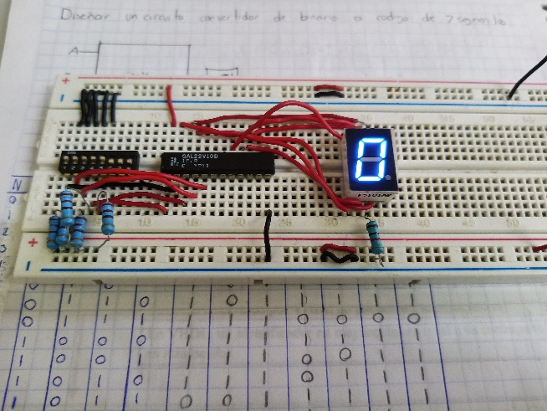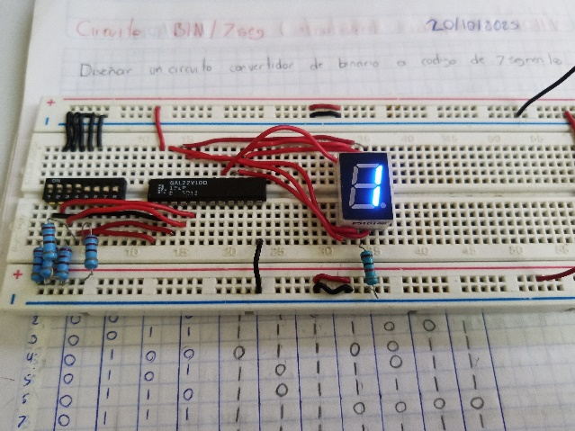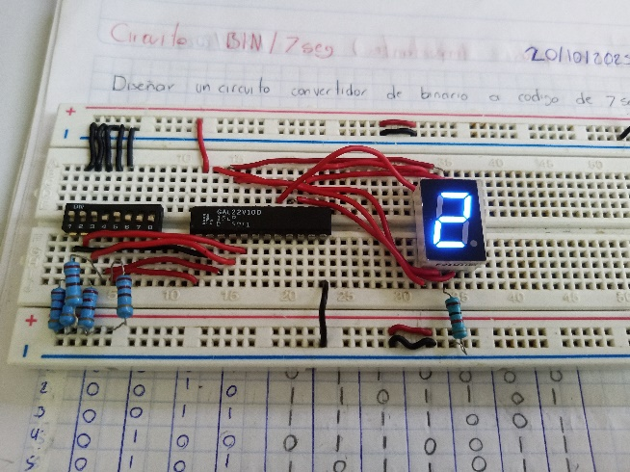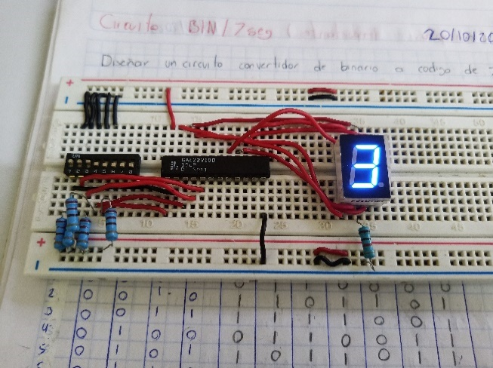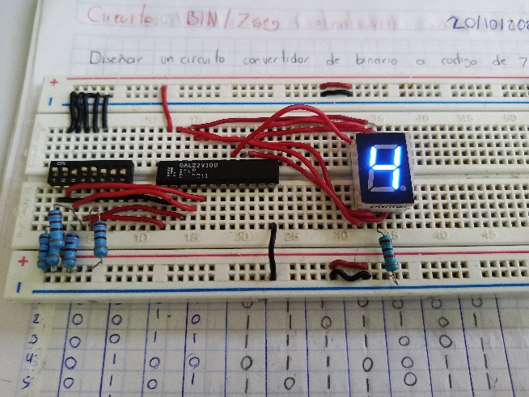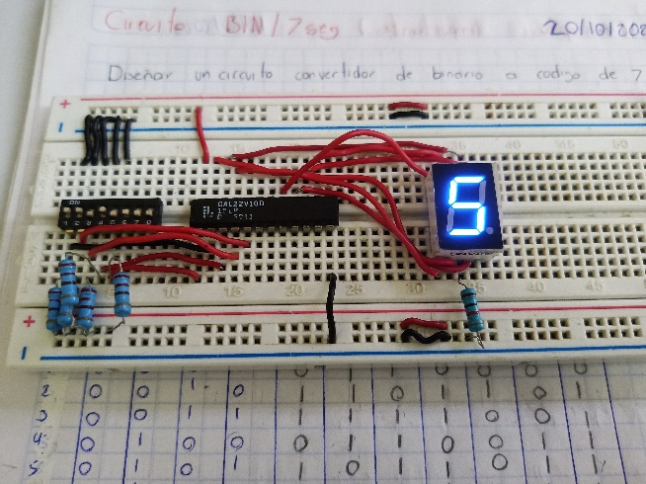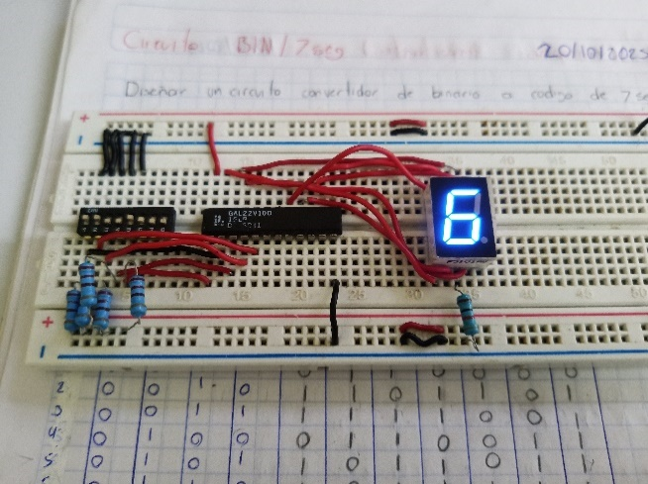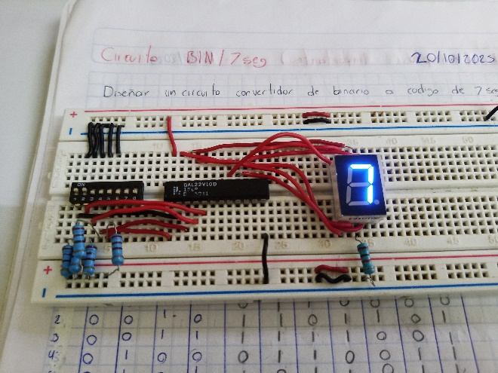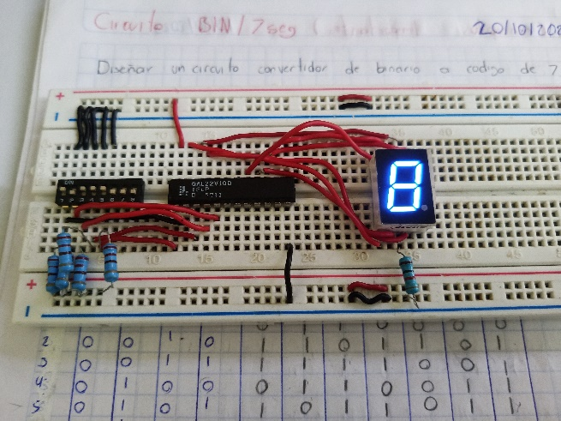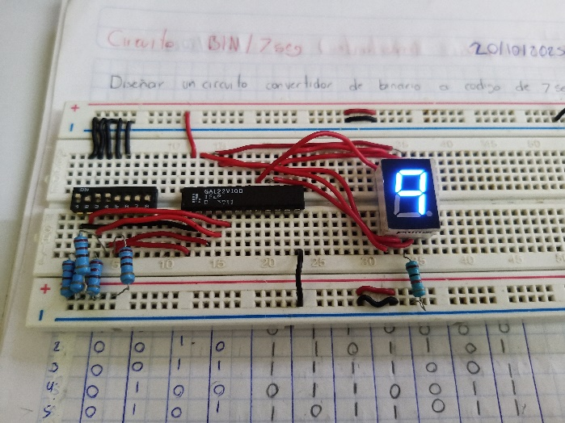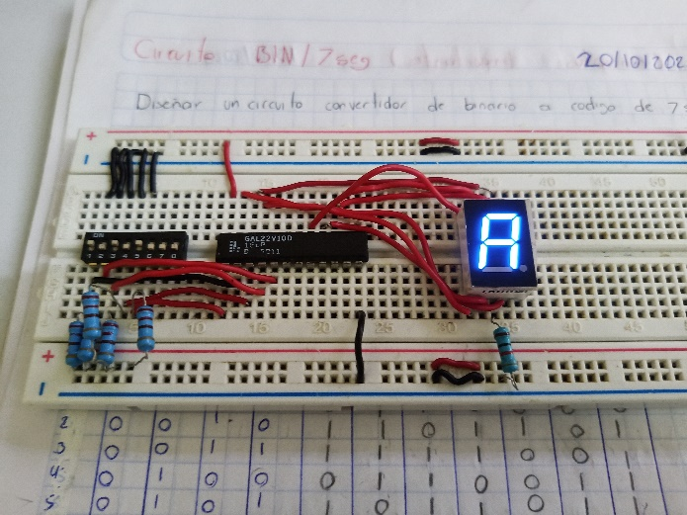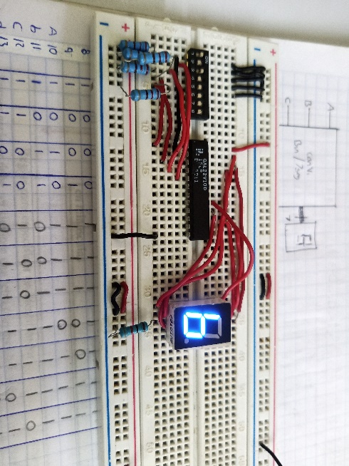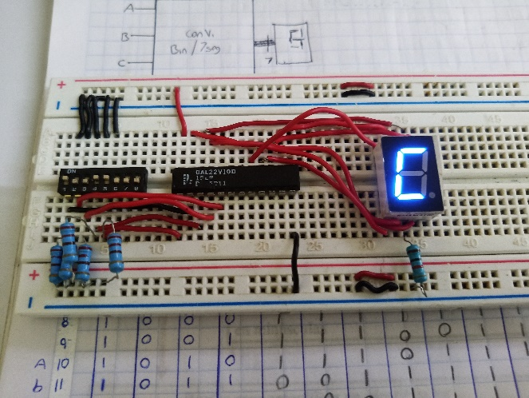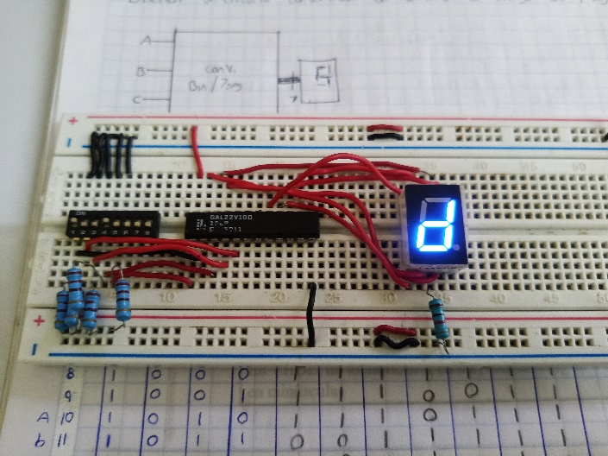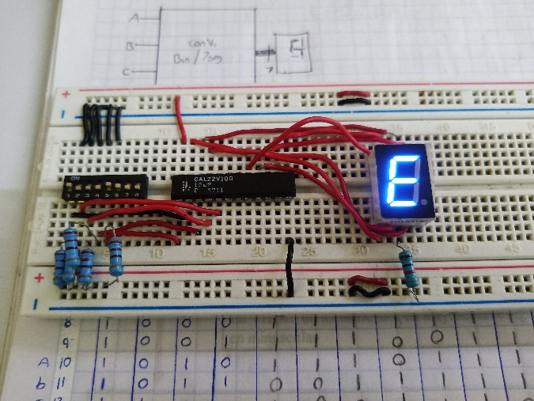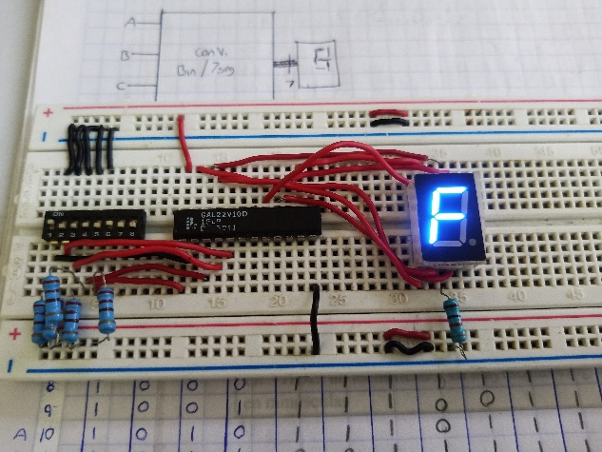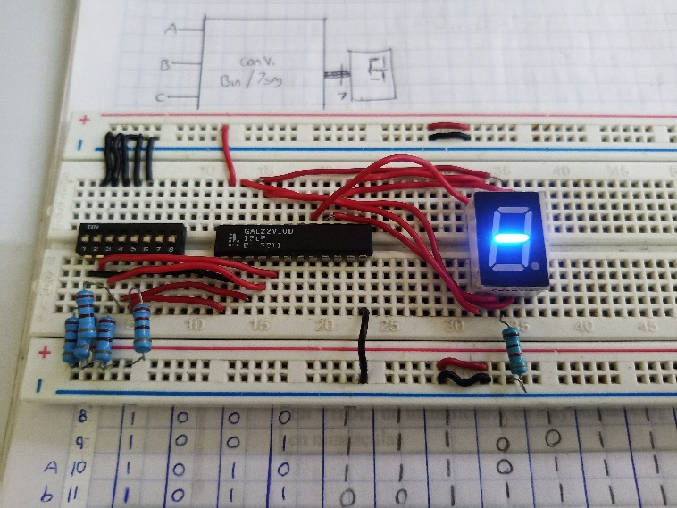
Capturas de la simulación realizada en VHDL Sim y/o PROTEUS:
